Itinerary

Flights
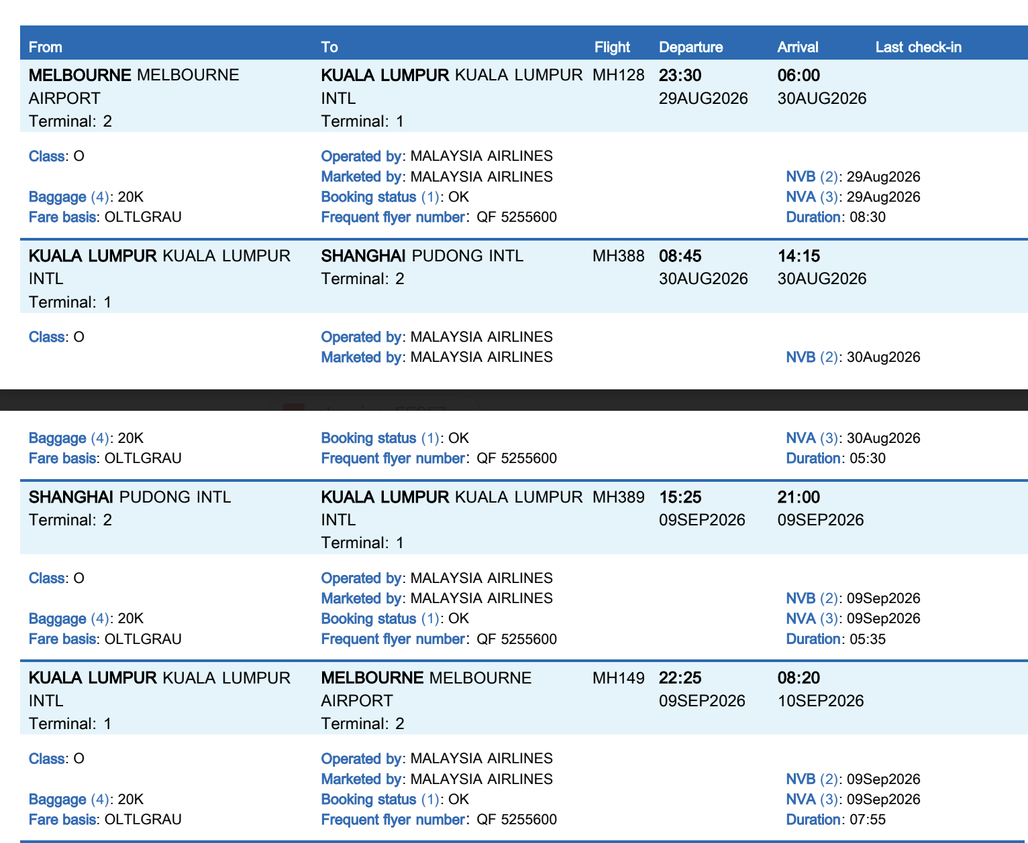

Hotels
Nanjing
Yin Hu Hotel (Wanda maoxianlin University Town Nanjing)
1st Floor, Block E, Wanda Mao, No. 24 Guangzhi Road, Xigang Street, Qixia District, Nanjing, Jiangsu, China


Shanghai
Zhexuejia Hotel (Shanghai Bund Xiaonanmen Subway Station) (check-in: Sep 5, 2026, check-out: Sep 9, 2026) is confirmed
Free cancellation - Before 23:59, Sep 5, 2026 (Hotel's local time)
Please check in using the guest name and the valid ID provided on the booking.
Hotel confirmation number: 9926072554102005
You can easily manage your booking via the button below

3rd Floor, No. 14, Lane 518, Zhonghua Road, Huangpu District, Shanghai, China

